VOLUNTEER COACH APPLICATION
Please circle the program(s) you are volunteering for
Basketball Baseball Softball T-ball Soccer Flag Football Swim Team Tumbling
Age group applying for:____________________________
Is this Community Service? Yes No Is this for an Internship? Yes No
Other Program / Activity applying for: ______________________________ Please check if under 18
This Photo by Unknown Author is licensed under CC BY-SA
Name as it appears on ID: ________________________________________________________
Current Address: ___________________________City: ____________ State: _____ Zip Code: ________
Phone______________________ Email_____________________________________________________
Have you volunteered for this program before? Yes No
Do you have a child in the program? Yes No Name of free child(1) entry __________________________
Do you have any experience or training specific to this sport(s)? Yes No
Do you have any previous experience as a volunteer in this position: Yes No
Explain:________________________________________________________________________________
______________________________________________________________________________________
______________________________________________________________________________________
Describe any other experience you have that relates to this program:_____________________________ _____________________________________________________________________________________ _____________________________________________________________________________________ _____________________________________________________________________________________
References: Please list names and contact information for two personal references other than family.
Name Address Phone Relationship _____________________________________________________________________________________ _____________________________________________________________________________________ _____________________________________________________________________________________
By applying with the Southern Valley County Recreation District to serve as a volunteer, I hereby consent to a
background/criminal check at no cost to me.

VOLUNTEER APPLICATION

Acknowledgement of Risk and Release I, the undersigned, agree for myself or for my minor child/ward, to volunteer for Southern Valley County Recreation District, and understand and agree to the following:
1. I agree that I will perform my volunteer service to the best of my ability, and will not engage in reckless or dangerous behavior while acting as a volunteer. I understand that as a volunteer I am required to follow the policies, procedures, rules for safety and any other regulations pertaining to the program(s) in which I volunteer.
2. I acknowledge that there are inherent dangers, hazards and risks associated with sports and activities in which I may serve as a volunteer. By accepting a volunteer position, I knowingly choose to assume all risks associated with such activities or sports including without limitation risk of injury or death. In addition, I assume all risk of damage or loss sustained to my property. I further agree and acknowledge that by assuming the risk of participation in the Southern Valley County Recreation District activities, I will not bring any action, claim or lawsuit against Southern Valley County Recreation District for injury, death or damage to my person or property arising, either directly or indirectly, from my role as a volunteer.
3. In the event of any emergency, I authorize Southern Valley County Recreation District officials to secure from any licensed hospital, physician and/or medical personnel any treatment deemed necessary for my immediate care, including ambulance transport. Further, I agree that I will be responsible for payment of any and all medical services rendered, and will indemnify and defend Southern Valley County Recreation District from claims, liens, charges, costs, or suits that arise as a result of any medical treatment or assistance I receive.
4. I understand that I am working at all times on a voluntary basis, and will not receive any compensation for my services. I realize that by volunteering for Southern Valley County Recreation District I am not employed by, nor am I an employee of the Southern Valley County Recreation District.
5. My relationship with the Southern Valley County Recreation District as a volunteer can be canceled or terminated at any time by the Department or by me, for any or no reason.
I have read and understand the Southern Valley County Recreation District "Acknowledgement of Risk and Release". Any minor's signature must be accompanied by the signature of a parent or legal guardian, whose signature shall constitute consent for said minor to volunteer with Southern Valley County Recreation District. Any person signing below further acknowledges that he or she has received, read and understands the Southern Valley County Recreation District Volunteer Policy.
Volunteer’s Name (printed)________________________________________________________

Signature of parent or guardian (if volunteer is a minor) _________________________________

Volunteer Signature________________________________________Date_____/_____/_______

Director Approval Signature _________________________________Date _____/_____/_______

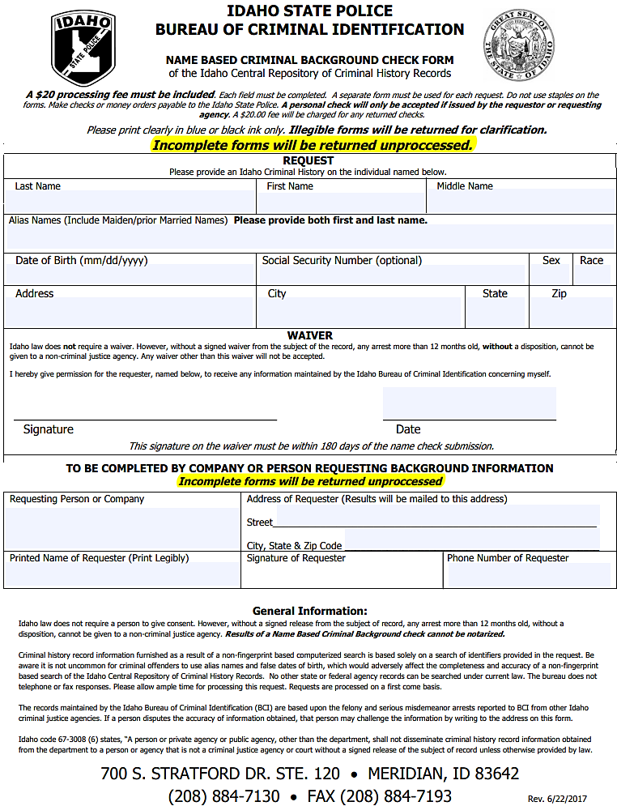
208-382-5136
Southern Valley County Rec District
Cascade ID 83611
PO BOX 723

