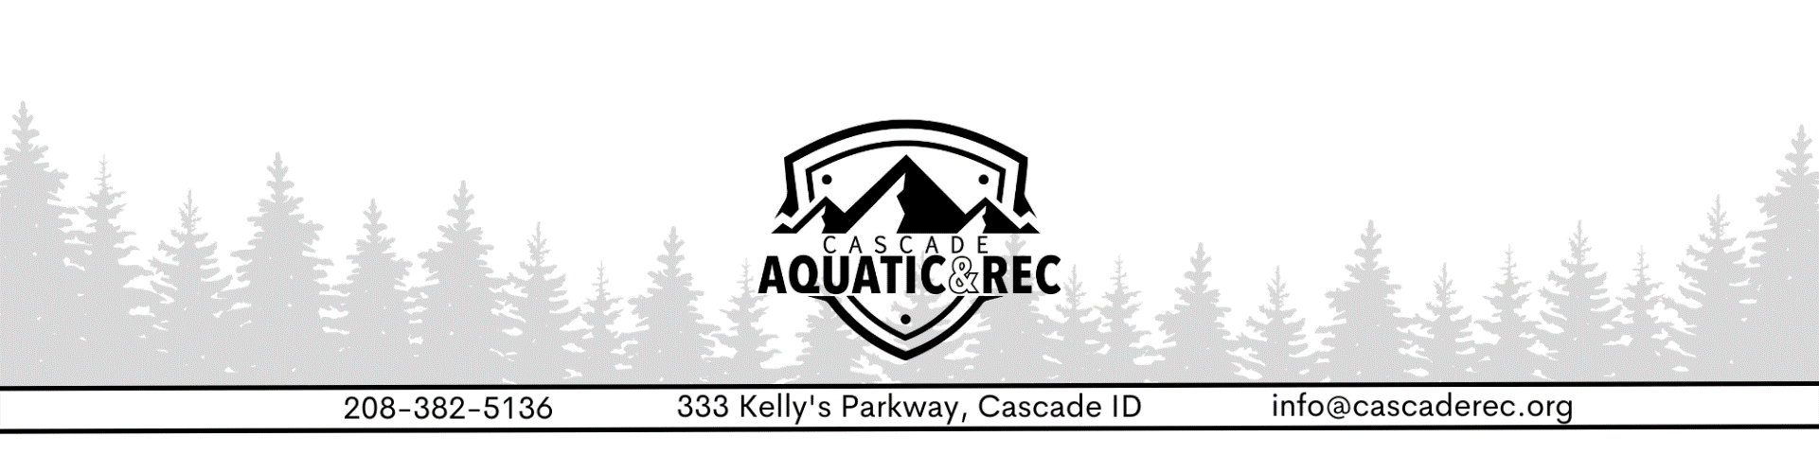
PURSUANT TO IDAHO CODE SECTION 74-204
REGULAR BOARD MEETING
THE SOUTHERN VALLEY COUNTY RECREATION DISTRICT
JANUARY 12th, 2023 @ 4:30 AM

Roll Call
Larry Morton – Board President
Patty Giardina – Board Member

Minutes Approval
December 22, 2022 Regular Meeting Minutes (Action Item)

Treasurer’s Report
December Financials

Manager’s Report
Facility
- IT: Phone & Internet
- Cameras
- Weight Room Age policy

Programs
- Basketball (End of Season)
- Nordic
- Ice Rink Update
- Youth Volleyball (Exploring options) 3rd -6th Grade
- Aquatics
- Cascade After School Program
Old Business
Insurance Review

New Business
Cascade Sports Park
Payroll Process
County Employee and Fire District Discount (Action Item)
New Board Members (Action Item)
Regular Board Meeting Schedule (Action Item)

